The title is here (for new line use shift+enter)
font: times new roman, bold, all caps, size 14
line spacing options: 18 points before
and 12 points after the paragraph
First Author’s First Name first author’s second name,
Second author, Third author, Professor COORDINATOR,
Font for the author’s first name: Times New Roman, regular, size 12,
font for the author’s second name:
Times new roman, all caps, size 12
Line spacing options: 0 points before and 18 points after the paragraph

Rezumat. Un singur paragraf, nu mai mult decât 10-12 rânduri (indentare: 0.63 cm stânga și 0.63 cm dreapta, opțiuni pentru spațierea rândurilor: 12 puncte înaintea paragrafului și 6 puncte după).

Abstract. A single paragraph, not more than 10-12 lines (font Times New Roman, italic, size 10; indentation: 0.63 cm left and 0.63 cm right, the line spacing options are: 12 points before the paragraph and 6 points after).

Keywords: Not more than five (font Times New Roman, regular, size 10; the line spacing options are: 0 before the paragraph and 0 after)
- Introduction (font Times New Roman, bold, size 12; line spacing options: 12 points before and 6 points after the paragraph)
Here is the first paragraph. Font Times New Roman, regular, size 12; line spacing options: 0 points before and 6 points after the paragraph.
Here is the second paragraph.
The entire article must have an even number of pages, between six and eight, recommendable six.
For the references use: [1] or [2, 3, 4] or [2-4].
- For new section header copy&paste this entire row, then replace the text
For inserting an equation in any position, select the entire row with an existing equation, copy & paste in the desired position, select & delete the old equation, insert the new one, then press simultaneously CTRL and A keys (=SELECT ALL), finally press F9 key.
For inserting equations you may use a 1x2 table (preferred width 14 cm) first cell=align center (preferred width 12.6), second cell=align right, preferred width 1.4):
$∇×E=−\frac{∂B}{∂t}$ | ()
For writing equations, use Math Type or Equation Editor; don’t forget impose the format for each category (the same as for the main text: font Times New Roman, size 12).
  - Subsection header (for new subsection header, select this row and use Format Painter for the new text, in the appropriate position)
The sub section paragraphs have the same formatting: Font Times New Roman, regular, size 12; line spacing options: 0 points before and 6 points after the paragraph.
For inserting figures follow the instructions below the figures.
For citing figures, use: see Figure 1, b.

Fig. 1 For a new figure, copy Fig. 1. at the left of this row and paste in the desired position.
a. Description; b. Description.
For a new equation don’t forget: after copying, press CTRL+A (=select all) then F9 key for the field be actualized.
$$∇×\left(\frac{1}{ε_{r}\left(r\right)}∇×H\left(r\right)\right)=−\frac{∂}{∂y}\left(\frac{1}{ε_{r}\left(x,y\right)}\frac{∂H_{z}}{∂y}\right)⋅e_{z}−\frac{∂}{∂x}\left(\frac{1}{ε_{r}\left(x,y\right)}\frac{∂H_{z}}{∂x}\right)⋅e_{z}$$ | ()
  - Second subsection header
The first paragraph for the second subsection (same formatting).
In a table you may insert images and equations if necessary, but the text must be legible.
The formula must have font size 10 points.
Table Title (font Times New Roman, regular, size 10; line spacing options: 12 points before and 6 points after the paragraph)
No. | Category | Category | Category
 | The text in the images must be legible! | 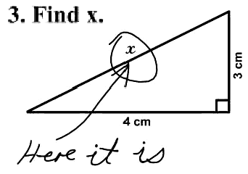 | Description
 | … | … | …
 | For formula use Math Type or EqEd | Formula | $$p=\frac{ν\text{TR}}{V}=1\text{.}\text{5 }⋅{\text{10}}^{5}\frac{N }{m^{2}}$$
 | Use decimal point! | Numerical value | 1234.67
You may group two or three figures: lock anchor, move with text, horizontal alignment=top of line, vertical alignment=centered, top & bottom wrapping.
Fig. 2 Description:
a. Text for a b. Text for b c. Text for c
second row for a. second row for b. second row for c.
For inserting a new table (text wrapping=around, distance from text=0.25, move with text) follow instructions below.
Table For new table, select & copy Table 2. in the left of this row and paste at the new position.
No. | Category | Category | Category
 | 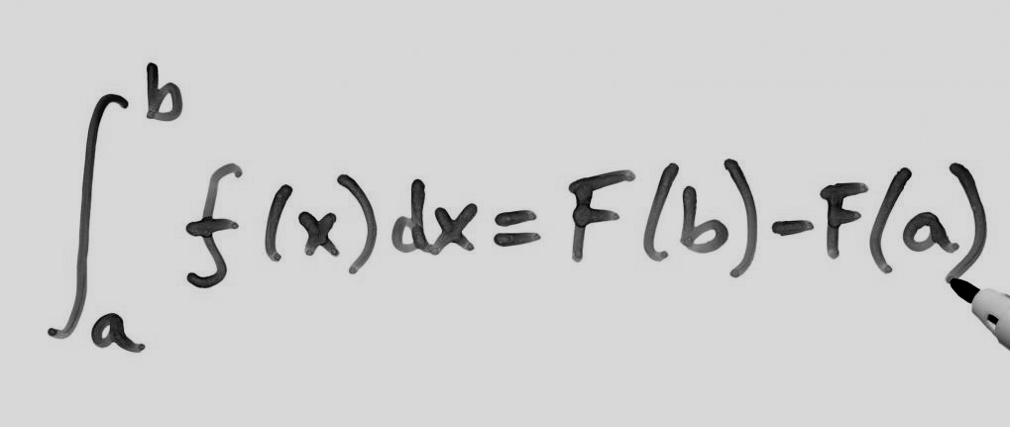 | Text
 | Symbols | μ | ●
 | Σ | ℜ | ⊗
Conclusions
Conclusion (1).
…
Conclusion (z).
Acknowledgment
Only if necessary.
Notations and/or Abbreviations
Only if necessary.
REFErences
For the title, use Times New Roman, bold, size 14, character spacing = 4, line spacing options: 24 points before paragraph, and 12 points after. For references, use 10 points fonts, line spacing=1.5. Use copy, paste, select & replace text. (You must delete this paragraph.)
- Book’s First Author, Book’s Second Author, Book’s title (Publisher, Town, Country, Year).
- Book’s First Author, Book’s Second Author, Book’s title (Publisher, Town, Country, Year) Vol. I, p. xxx or pp. xxx-xxx.
- Article’s First Author, Article’s Second Author, Review’s name (=international abbreviation), 24 (=volume number, bold), xx (=page number where the article begins) (Year).
- Article’s title, web page’s address http://xxxxxx/xx/xxxx/xxxxx/htm.
- G. Gamow, Z. Phys. 51, 204 (1928).
- D. Forster, Hydrodynamic Fluctuations (Benjamin, New York, 1975) Vol. I, p. 25.
- P. Ring and P. Schuck, The Nuclear Many-Body Problem (Springer-Verlag, Berlin, 1980).
- A. Sandulescu and O. Dumitrescu, Phys. Lett. B 24, 212 (1967).
- E. S. Paul et al., Phys. Rev. C 61, 064320 (2000).
- V. G. Soloviev, Theory of Atomic Nuclei (Institute of Physics Publishing, Bristol, 1992) pp. 123-125.
- Rare isotope accelerator. Argonne web p., www.anl.gov/ria.

Title: Prof., PhD, PhD (ABD), Eng., Senior/Junior Researcher etc., affiliation: Faculty, Chair, Institute, University, City, Country, full/corresponding member of the Romanian Academy - if the case (e-mail: abc@def.net).
Eng., PhD, Name Department, “Name” Institute, City, Country, (abc@def.net)).
Senior Researcher, “Name” Institute, City, Country (abc@def.net).
Prof., PhD, Faculty of Name, University “Name”, City, Country, (abc@def.net)..

